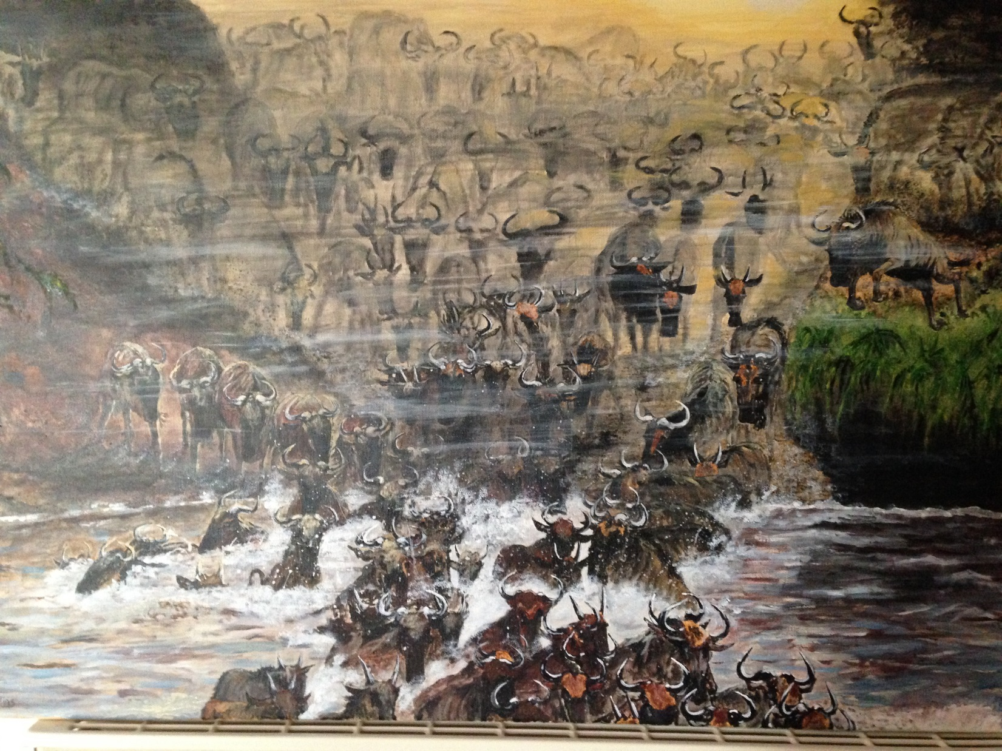

Wildebeest
  - £150.00
Acrylic on canvas wooden structure (0.5” deep)
No frame required
Ready to hang

